**Saint Brigid St. John the Baptist**

29th Sunday in

Ordinary Time

October 21, 2018

**Catholic Church Catholic Church**

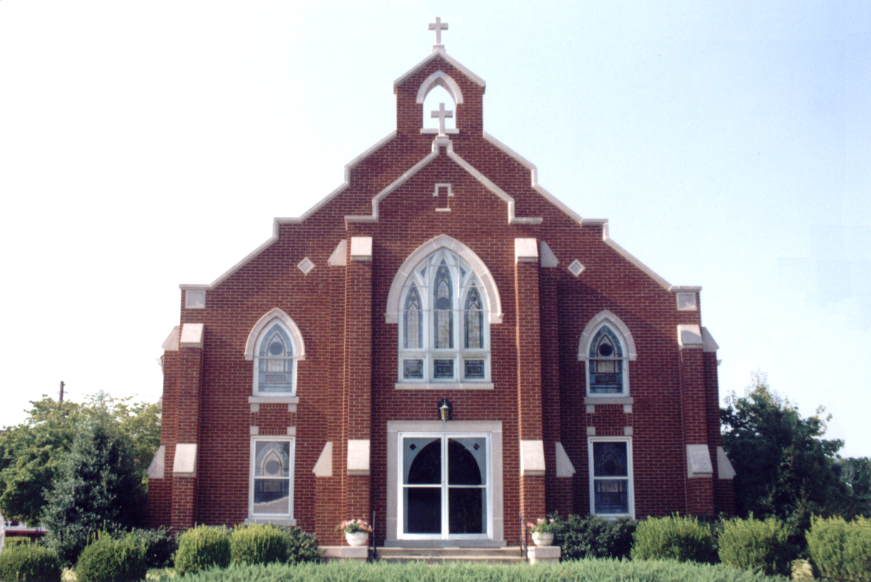

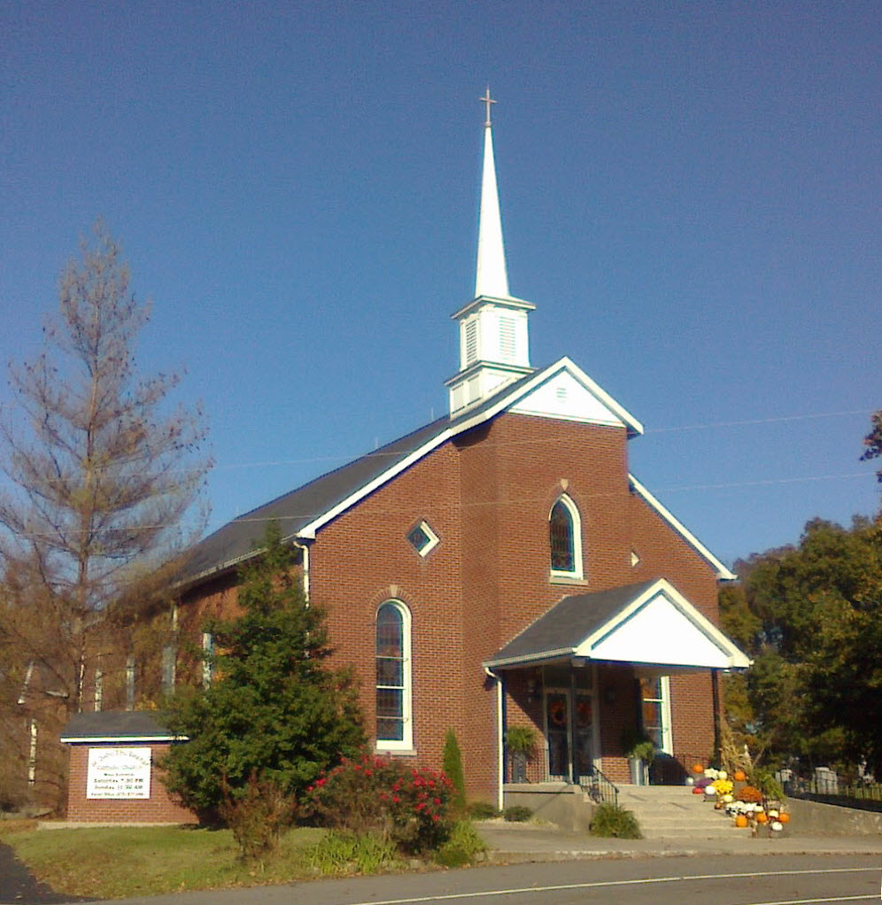

21

**Pastor:**

***Rev. Daniel L. Lincoln***

Rectory: (270) 877-2546

**Deacon:**

***Michael A. Ryan***

(270) 272-6789

314 E. Main St. 657 St. John Church Rd.

Vine Grove, KY 40175 Elizabethtown, KY 42701

Clustered Parish Office: Clustered Parish Office:

**ANNOINTING OF THE SICK:**

Notify the parish office when a family member is hospitalized.

**BAPTISM:**

Contact the parish office for information about the required preparation class.

**BULLETIN:**

Information must be submitted in writing by note or email to the parish office **no later than 12:00 noon on Wednesdays** for the following weekend. When sending an email, please put “BULLETIN,” and the name of the parish the announcement is for, in the subject line.

**MARRIAGE:**

Contact Father at least 6 months prior to the wedding date to complete required marriage preparations and to schedule the date.

**RCIA (Rite of Christian Initiation of Adults):**

Contact the Worship Chairperson for information.

**DEW MEMORIAL LIBRARY:**

(in St. Brigid Church basement):

Open: Sunday after 9:30 a.m. Mass& 45 minutes before all other Masses.

(270) 877-2461 (270) 877-2461

Email: [brigidvg@bbtel.com](mailto:brigidvg@bbtel.com) **Dir. of Religious Education:**

Website: [www.stbrigidvg.org](http://www.stbrigidvg.org)Lisa Thomas: (270) 735-6930

**Pastoral Associate & Dir. Youth Ministers:**

**of Religious Education:** Angela Churchman:

Deacon Mike Ryan: (270) 877-0546 (270) 268-9963

**Youth Minister:** Ericka Finlay: (502) 612-2644

Lori Law: (270) 723-0157

**MASS SCHEDULE:**

*Saturday (Vigil):*  6:30 p.m.

*Sunday:* 11:30 a.m.

*Wednesday:* 6:30 p.m.

*Friday:* 9:00 a.m.

**RECONCILIATION:**

Saturday before Mass

5:30-6:00p.m. or by appt.

**PARISH COUNCIL MEMBERS:**

*President:* Lauran Thomas

*Secretary:* Theresa Smith

**CHAIRPERSONS:**

*Administration:*  Nick Thomas

*Formation:* Ericka Finlay

*Parish Life:* Bradley Wickersham

*Worship:* Greg Thompson



**MASS SCHEDULE:**

*Sunday:* 9:30 a.m. & 6:30 p.m.

*Monday:* 9:00 a.m.

*Thursday:* 9:00 a.m.

**RECONCILIATION:**

Sunday before Mass

5:30-6:00 p.m. or by appt.

**ROSARY:**

After weekday Masses

**PARISH COUNCIL MEMBERS:**

*President:* Sue Weisshaupt

*Vice-President:* Mike Bramlett

*Secretary:* Judy Cochran

*At-Large Members:* Blake Ryan

& Vincent Thompson

**CHAIRPERSONS:**

*Administration:* Dale Winchester

*Formation:* Tina Yates

*Parish Life:* Tom Billings

*Worship:* Keith Baughman



|  |  |  |  |  |  |
| --- | --- | --- | --- | --- | --- |
| **Saturday** | **October 20** | **6:30 p.m.** | **St. John** | **For All Parishioners** | **Vigil: 29th Sunday in Ordinary Time** |
| **Sunday** | **October 21** | **9:30 a.m.** | **St. Brigid** | **Mack, Leanna & Billy Cecil** | **29th Sunday in Ordinary Time** |
| **“** | **“** | **11:30 a.m.** | **St. John** | **Bruce & Margaret Lincoln** | **“** |
| **“** | **“** | **6:30 p.m.** | **St. Brigid** | **Our Parish Family**  **Hellen C. Adams** | **“** |
| **Monday** | **October 22** | **9:00 a.m.** | **St. Brigid** | **Richard Hughes**  **Inge Luther, Cameron Ponder**  **& Luise Weisshaupt** | **Weekday** |
| **Wednesday** | **October 24** | **6:30 p.m.** | **St. John** | **Fr. Stan Osborne** | **Weekday** |
| **Thursday** | **October 25** | **9:00 a.m.** | **St. Brigid** | **Dickie Cecil**  **Dale Boswell** | **Weekday** |
| **Friday** | **October 26** | **9:00 a.m.** | **St. John** | **Philip Whelan** | **Weekday** |
| **Saturday** | **October 27** | **6:30 p.m.** | **St. John** | **Fr. Stan Osborne** | **Vigil: 30th Sunday in Ordinary Time** |
| **Sunday** | **October 28** | **9:30 a.m.** | **St. Brigid** | **Joe Stith** | **30th Sunday in Ordinary Time** |
| **“** | **“** | **11:30 a.m.** | **St. John** | **For All Parishioners** | **“** |
| **“** | “ | **6:30 p.m.** | **St. Brigid** | **Our Parish Family**  **Rose Marie Yates** | **“** |

**For Both Parishes**

**VOCATIONS** – Do you know a young man or woman who might make a great priest, brother or sister? Help the Archdiocese of Louisville Vocations Office connect with them! By submitting names through our Called by Name initiative, you'll help us send potential discerners good information and invitations to discernment events. To participate visit: [www.louisvillevocations.com/called-by-name/](http://www.louisvillevocations.com/called-by-name/)

**ABORTION AND ADOPTION –** The number of would-be adoptive parents (of newborn babies) far outstrips the supply in America. Each year in the United States, about 135,000 American children are placed for adoption. Experts estimate somewhere between one and two million couples seek to adopt yearly. Every year, there are about 1.3 million abortions. Sadly, only 4% of women with unwanted pregnancies give their children up for adoption. Every child is wanted and wanted desperately! By Pro-Life Articles Author [www.pro-lifearticles.org](http://www.pro-lifearticles.org)

**PROJECT RACHEL** **–** Healing…Forgiveness…Hope…After the experience of an abortion. If you or someone you know is struggling with the pain from an abortion, please consider Project Rachel – a post abortion ministry. To speak to someone confidentially, call (502) 471-2155 or email [ProjectRachel@archlou.org](mailto:ProjectRachel@archlou.org).

**CONFIDENTIAL PREGNANCY AND ADOPTION COUNSELING** – is available at Catholic Charities for women of all ages experiencing untimely pregnancies. A full range of services are provided, including adoptive placement, legal assistance and counseling for individuals, groups and families. Post-abortion counseling is also available. Services are provided regardless of income or marital status. For more information, call Catholic Charities at (502) 637-9786.

**FAMILY DAY SUNDAY, OCTOBER 27** – The Knights of Columbus 3379 invite the community for a food, fun and Fellowship. Please bring a side dish. Meats and drinks will be provided. No need to RSVP. Games, Pumpkin carving, gold and much more! Begins at 1:00 p.m.

**THE ST. MARTIN’S ARCHIVE COMMITTEE FUNDRAISER** – The Monarchs will perform in the St. Marin Gum on **Saturday, November 3, from 7:00-10:00 p.m.**  Because we have several very generous sponsors we are able to accept $15 donation to attend. This money will be use for the renovations and upkeep of the archives. For anyone who not familiar, the Monarchs, from Louisville, played music from the 50’s, 60’s and 70’s. There will be something for everyone if you want to dance or just listen. Our “theme” is Senior Prom,” Junior of you’re under 70!! Dress the way you want for the prom – casual, formal or somewhere in between. If you loved your prom – relive it. If you did not love your prom – remake it. If you never had a prom – here is your chance. The Locals food truck will be at the gym from 6:00-8:00 p.m. or as long as they are busy. You may bring snacks and drinks. **No Alcohol please**. Everyone is welcome.

**St. John and St. Brigid Prayer List**

To add someone to the prayer list, please call the parish office at (270) 877-2461. **Remember to call to remove someone from the list if they are no longer sick, etc.** *Please note that the prayer list has been revised. It is primarily for parishioners and their immediate family members*.

Leslie **Adams-Cerniglia**, Sam **Adams**, April **Allen**, Dennis **Arnold**, Barbara **Ashley**, Donnie Alan **Atcher**, Sue **Banks**, Shannon **Barnes,** Denise **Barnett**, Timothy **Birch**, Teresa **Blaycock**, Charlie **Bowers**, Pauline **Brangers**, Ellen **Bryan**, Richard **Bryson**, Carol **Buchanan**, Linda **Buchanan**, Jeremy & Margie **Buyer**, Deacon Bob **Caspar**, Sue **Caswell**, Ed **Cecil**, J. Mack **Cecil**, Steve **Cecil**, Harlan Ford **Clark**, Judy **Cleaver**, John **Connor**, Betty Jo **Cooper**, Heidi **Correa**, Jeff **Craig**, Glynn **Clutches**, Roan **Dowell**, Karen **Dworshak**, Leroy **Embry**, Marion **French**, Martha **Ford**, Dwayne **Garcia**, Carrie **Gribben**, Mary **Hager**, Mrs. Charles **Hair**, Stephanie **Hall**, Donnie **Hart**, Jimmy **Harper**, Bobby **Harris**, Eileen **Heinen**, Debbie **Hodge**, Betty Lou **Jones**, Charlene **Langley**, Olivia **Leasor**, Jenny **Leonhardt**, Jackie **Long**, Louise **Lucous**, Alma **Mahanna**, Shelly **Martin**, Shirley **Martin**, Martina **Masoni**, Don **Mattingly**, Gerard **Mattingly**, Paul Michael **Mattingly**, Mary **Medley,** Cindy **Miller**, Starla **Miller**, Doug **Osborne**, Duane **Osborne**, Mickey **Padgett**, Frank **Inanely**, Jerry **Phillips**, Annie **Pierce**, Adrianna **Porter**, Jeremy **Porter**, Adrian **Ray**, Allie **Ray**, Mary Agnes **Ray**, Mary Ellen **Ray**, Tonya **Reisinger**, Joel **Rivera**, Caroline **Seabee**, Leon **Skeeters**, Jim **Smith**, Ralph **Staples**, Keith **Tassin**, Anthony **Thomas**, Kenny **Thompson**, Raffaella **Tucker**, Debi **Turner**, Stacey **Vance**, Bill **Waldrop**, Lois **Weaver**, De Neil **Whelan**, Paul A. **Whelan**, Jennifer **Williams**, Sandy **Wiseman**, Zach **Wiseman**, Gail **Wilson**, Don **Wooldridge**, Connor **Wright**, and all the sick, both mentally and physically.

**OUR MILITARY List**

To add someone to the military list, please call the parish office at (270) 877-2461. **Remember to call to remove someone from the list if they are no longer in the service**.

Lt. Matt **Bednar**, PFC Richard H. **Chapman**, A1C Aaron **Chandler**, A1C Brandon **Davila**, SrA Felicia **Esquivel**, PFC Tyler **Hall**, A1C Ryan **Henley**, A1C Joseph **Manco**, SPC Jacob L. **Nall**, SFC Peter **Novak**, Tony **Rickerl**, James **Rogers**, Tony **Rogers**, Jonathon **Sifford**, Jeffrey **Slade**, Derek **Smith**, CSM Vance **Snider**, Brian **Tomassi**, A1C Daniel **Trombone**, SGT Evan **Vaughan**, PV2 William **Vaughan**, SFC Lisa **Flynn-Veri**, CPT Michael **Veri**, LTC Steve **Wickersham**, SGT Clay **Wilson**, TSGT Jeremy **Yates**, Austin **Zulka** and for all who serve and have served our country.

**St. John The Baptist catholic church**

**Monthly Budget Amount Needed:** $ 12,500.00

**Monthly Collection for September:** $ 12,268.00

**Monthly Collection for October:** $ 8,639.50

**WELCOME PACKETS** – If you would like to become a member, or learn more about St. John Parish, please take a *Welcome Packet* in the church lobby. You may return the census card and the stewardship form to Father Dan or place in the collection basket.

**CATHOLIC SERVICES APPEAL 2018** – Our financial goal this year is $21,900. Our participation goal is 96 families. Let us respond promptly and generously this year.

**FEAST OF ALL SAINTS MASS** – Holy Day Mass will be **Wednesday, October 31, at 5:30 p.m.**

**CONGRATULATIONS** – TO Gabe Pike and Emily Bohannan who were married at St. John last Saturday. May God bless their lives together.

**THE DISCERNMENT SERVICE/OUTREACH SUB GROUP** – will meet next **Wednesday, October 24,** at following the 6:30 p.m. Mass. We will be discussing projects that this group may wish to do especially the upcoming participation with the Room in the Inn. St John Church will be hosting 1 night during the month of December, January, February. If

you are unable to attend the meeting, please feel free to call me, Elaine Geer @ (270) 737-4172 or (270) 763-2202.

**PARISH COUNCIL** – will meet on **Monday, October 29, at 6:30 p.m.** in the Parish Hall.

**SMALL GROUP STUDY –**  sessions will be resuming later this month.  There will be two opportunities - **Sunday** nights at 6:00 p.m. starting **October 28** and **Monday** nights at 6:30 p.m. starting **October 29**.  These sessions will run for four consecutive weeks.  The Sunday night group will be meeting in the lower level of the Parish Hall with Clarissa Yates and Lisa Thomas facilitating.  The Monday night group will meet at Two Taylor Catering in Rineyville with Paul and Diane Taylor facilitating.  We will be using the series *"A Minute in the Church"* by Gus Lloyd on *"The Mass".*  This series focus is on one-minute explanations about the Catholic Mass with follow-up references to the Catechism and Bible passages.  These groups are open to anyone interested in attending no prior registration required.  This is an excellent way to prepare our hearts for the coming Advent season and to learn about the Mass.  Any questions contact Lisa Thomas at (270) 735-6930 or [glalt@comcast.net](mailto:glalt@comcast.net)

**CEMETERY BLESSING** – Weather permitting, our annual cemetery blessing will take place after the 11:30 a.m. Mass on **Sunday, November 4.**

**SAFE ENVIRONMENT TRAINING –** St. John will be hosting a Safe Environment Training on **Monday, November 12,** at 6:30 p.m. in the Parish Hall.  This training is required one time only for anyone volunteering with our youth or any other potentially vulnerable individuals.  The training lasts approximately 1 to 1 1/2 hours.  Anyone volunteering with the Religious Education Program or Vacation Bible School must have this training.  No pre-registration is required.  Any questions contact Lisa Thomas (270) 735-6930 or [glalt@comcast.net](mailto:glalt@comcast.net)

**ROOM IN THE INN** – St. John The Baptist will sponsor the Friday nights of **December 28, January 25, and February 22** for this program to help the homeless in our area. Contact Elaine Geer at (270) 763-2202 or (270) 737-4172 to volunteer or for more information.

**St. John liturgical ministers**

|  |  |
| --- | --- |
| **Vigil: 30th Sunday in Ordinary Time, October 27, 2018** | **6:30 p.m.** |
| Extraordinary Ministers of the Eucharist | Joanna Sherrard Lori Shinault Amy Thomas |
| Lector | Dennis Thomas |
| Servers | Claire Thomas Drew Thomas |
| Greeter(s) | Vicki Taylor |
| Gift Bearers | Newton Family |
| - Ushers | John Thomas Zach Thomas |
| **30th Sunday in Ordinary Time, October 28, 2018** | **11:30 a.m.** |
| Extraordinary Ministers of the Eucharist | Lisa Parrett Jose Resto-Vargas Jennifer Updegraff |
| Lector | Joe Vititoe |
| Servers | Jake Ovensen Jacob Sullivan |
| Greeter(s) | Martha Thomas |
| Gift Bearers | Tim Wiseman Family |
| Ushers | Brandon Wiseman Trent Thomas |
| **Hospital Ministry – Sunday, October 28, 2018** | Martha Thomas & Lauran Thomas |

**St. Brigid catholic church**

**Monthly Budget Amount Needed:** $ 25,280.00

**Monthly Collection for September:** $ 28,895.29

**Monthly Collection for October:** $ 15,160.50

**WELCOME VISITORS** – If you are interested in joining our parish, please pick up a Welcome Packet at the church doors. Complete the registration form and either drop it in the collection basket or mail it to the office. If you just need to update your registration, there are also forms available.

**MISSAL COVERS** – It’s that time of year again to remove the missal covers and place them in baskets at the doors of the church so we can cover the new missals for the first Sunday of Advent. Should you have any questions please call Deacon Mike.

**CATHOLIC SERVICES APPEAL 2018** – Our financial goal this year is $35,500. Our participation goal is 129 families. Let us respond promptly and generously this year.

**ST. VINCENT DE PAUL SOCIETY** – Because of tax law changes all donations to SVDP should be made out to St. Vincent de Paul NOT to St. Brigid Church. Your donation is still tax deductible. THANK YOU for your continued support of SVDP to help the local poor and needy.

**FROM THE LIBRARY** – **>** There is now an Accelerated Reader section in the library.  Books are labeled by grade level K-8.  Please read and return the book to the correct tub.  Good luck on your testing at school! **>** There is a High School reading section geared toward college bound.  Read and return. **>** Four tables are full of free adult reading.  Read and pass along. **>** The kid table is full of books to be read and returned.  Many new choices. > The large circle table is now a Genealogy resource.  Books need to be checked out and returned. **>** Dr. Dew’s library is still intact.  Read and return where you got them. **>** Thanks to those who have donated books for all to enjoy!

**TOOTSTIE ROLL DRIVE** – that benefits all ages with developmental disabilities. They fun camps, give to worthy charities such as Special Olympics. The Knights of Columbus 3379 from Vine Grove will be collecting at the back of church on **Sunday, October 28.**

**PARISH COUNCIL** – will meet on **Thursday, October 25, at 7:00 p.m.**

**FEAST OF ALL SAINTS MASS** – Holy Day Mass will be **Thursday, November 1, at 9:00 a.m.**

**CEMETERY BLESSING** – Weather permitting, our annual cemetery blessing will take place at 4:00 p.m. on **Sunday, November 4.**

**CHRISTMAS FOOD BASKET –** The K of C 3379 Vine Grove Council asks that if you know anyone in need of a Christmas Food Basket, please contact Danny Greenwell at (270) 766-7914 until December 2, 2018.

**BLOOD DRIVE** – The next drive will be held on **Friday, December 14,** from 10:00 a.m.-2:00 p.m. in the CCC building. Give the gift of life!! This is more rewarding than what else you have to do today!!

**St. Brigid youth ministry**

**Wednesday, October 24** – Youth Open Gym in the CCC for all 8th-12th graders from 6:30-8:30 p.m. Our new year of youth group is just getting started. If you have never come to open gym or other youth events in the past, now is a good time to get started. Join us for games, play ball, socialize or bring something new to the group.

**Saturday, October 27** – **Fall Gathering at the Fowler’s** – Scott, Mary & Kyle Fowler have opened their home and invited our youth group to a Fall Gathering at 6:00 p.m. All 8th-12th graders are welcome to come out for an evening of good food and fun activities. Please **RSVP by WEDNESDAY, OCTOBER 24.** I will give you their address and directions, if needed, when you RSVP.

**Wednesday, October 31 –** **Trunk or Treat –** All 8th-12th graders are needed at 4:30 p.m. (or when you can get there) to help set up for Trunk or Treat. During the event we will be working the concession stand and running a table. Feel free to dress up but **no masks please**. We will help clean up and should finish up about 9:00 p.m.

If you have any questions, please contact Lori at (270) 723-0157 or email at [stbrigidyouth@hotmail.com](mailto:stbrigidyouth@hotmail.com).

**St. Brigid monthly meet and greet**



St. Brigid Parish hosts a “Meet and Greet” in the School Cafeteria the 2nd Sunday of each month immediately following the 9:30 a.m. Mass with coffee and donuts. This is a great opportunity for existing parishioners to extend a warm welcome to visitors and anyone interested in joining St. Brigid Parish. Be sure to also visit the Dew Memorial Library.

**The next Meet and Greet will be Sunday, November 11, 2018.**

**St. Brigid liturgical ministers**

|  |  |
| --- | --- |
| **29th Sunday in Ordinary Time, October 21, 2018** | **9:30 a.m.** |
| Extraordinary Ministers of the Eucharist P. | Denise Hester Janey Jenkins |
| C. | Butch & Nan Filburn E. Jane Vessels |
| Lector | Blake Ryan |
| Servers | Maggie Board Cal Yates |
| Greeters |  |
| **29th Sunday in Ordinary Time, October 21, 2018** | **6:30 p.m.** |
| Extraordinary Ministers of the Eucharist P. | Richard Osterhage |
| C. | Donna Osterhage |
| Lector | Richard Osterhage |
| Servers | Jackie Veri |
| Greeters | Volunteers |
| **Hospital Ministry – Sunday, October 14, 2018** | Ralph and Sherleen Barren |

**St. Brigid faith formation news**



**FAITH FORMATION NEWS**

Pack Your Trunks and Get Ready for a Treat!

St. Brigid hosts our Annual Trunk or Treat on **Wednesday, October 31,** during Vine Grove’s Trick or Treat hours.

Set-up no later than 5:30 p.m. in the indoor comfort of the CCC. Pick out your spot and go wild with decorations for “your trunk”!! Costumes welcome. No masks please!

Questions? Call Selina Chandler at (270) 765-3672.

**MARRIAGE MOMENTS**

It is natural to want stuff – food, clothing, shelter are necessities. Fashionable clothes, eating out and electronics are not evil. BUT, how do you reconcile these desires with “How hard it is for those who have wealth to enter the kingdom of God?” (Mark 10:23) How much is enough? Decide at least one thing to give away today.

**PARENTING POINTERS**

Children make mistakes. That’s natural. Of course you forgive them. For example, they may promise to never drink and drive again. Believe them. But this doesn’t mean you enable a teen by being blind to reality. Forgive but verify. (Parenting Your Adult Child)